**Solutions – Assessment 6 BDA Meldrum,etc**

|  |  |
| --- | --- |
| **1** | **C** |
| **2** | **D** |
| **3** | **removed** |
| **4** | **C** |
| **5** | **B** |
| **6** | **B** |
| **7** | **A** |

8. What is the difference between **cash** and **accrual accounting**? [4 marks]

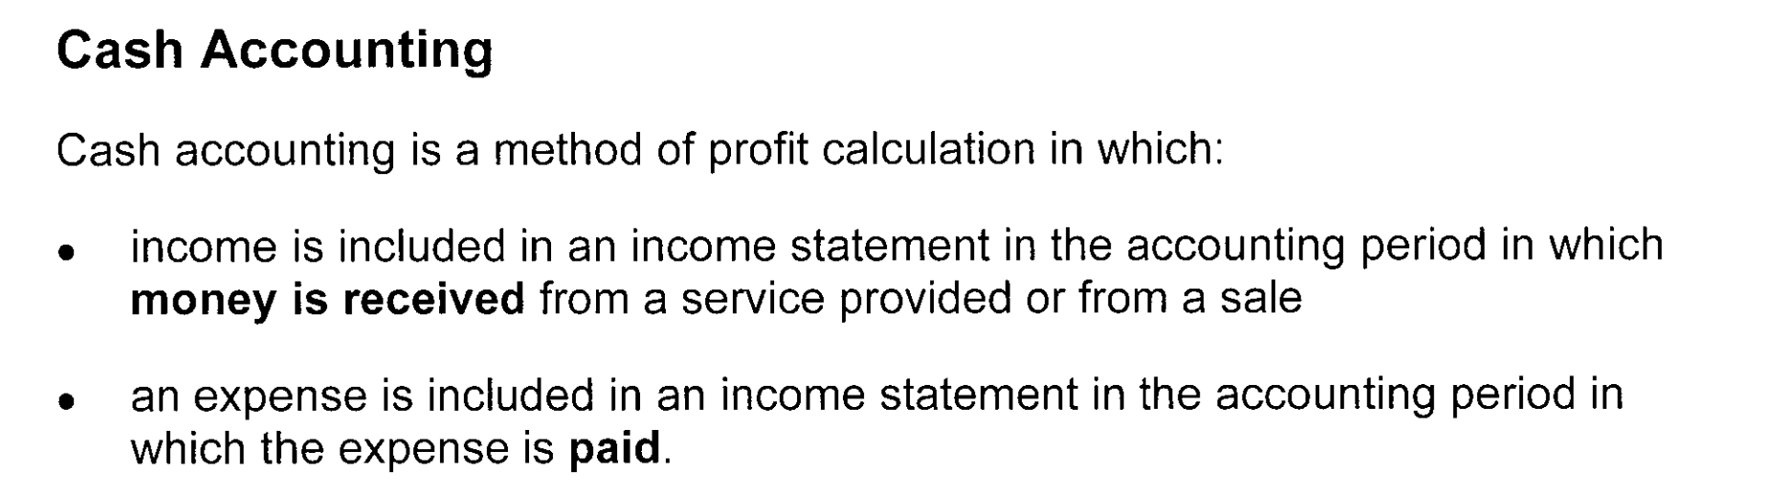

**1**

**1**

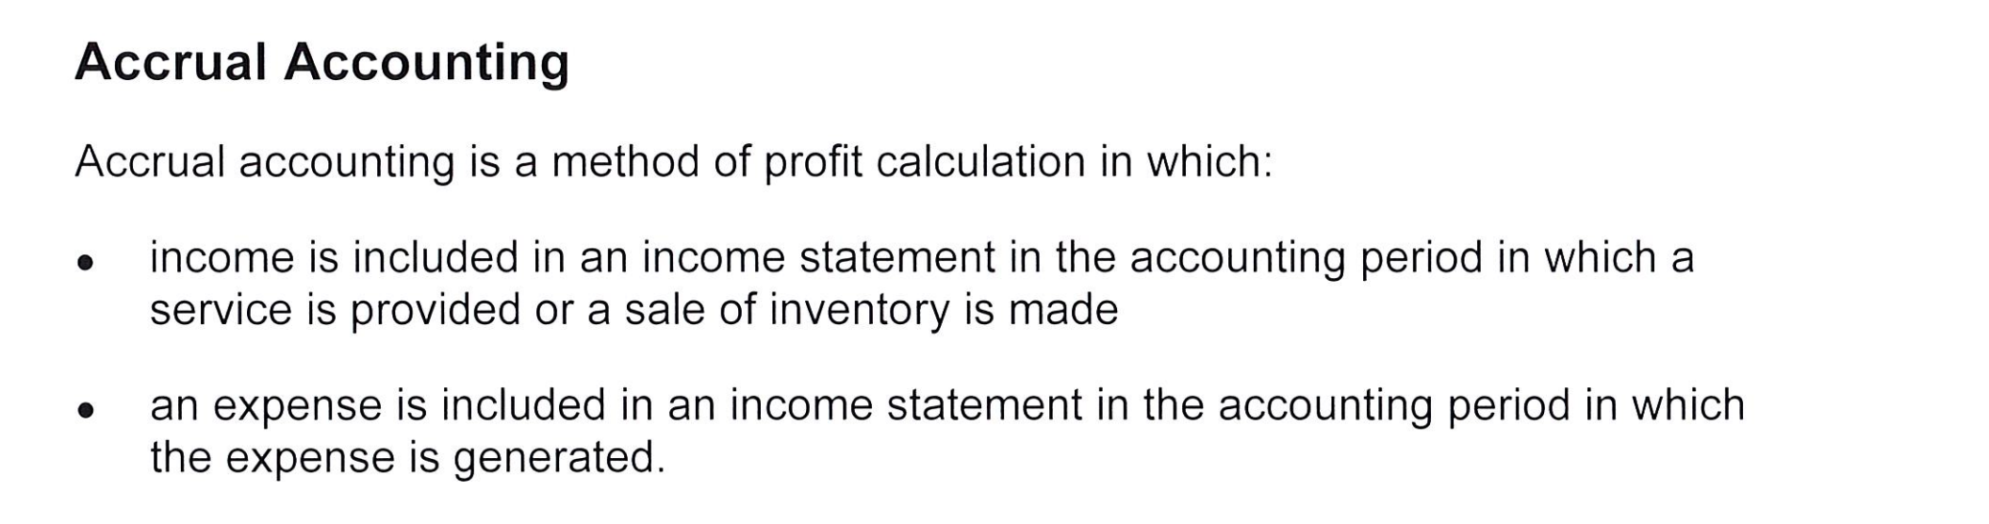

**1**

**1**

9. What is the difference between **bad debts** and **doubtful debts**? [4 marks]

**Bad Debts**

Are money to the business that needs to be written off as there is certainty that the money cannot and will never be paid after a reasonable period has passed**. (1)** The business then decides that since the money will definitely not be received from the customer, it will get written off by crediting account receivable. **(1)**

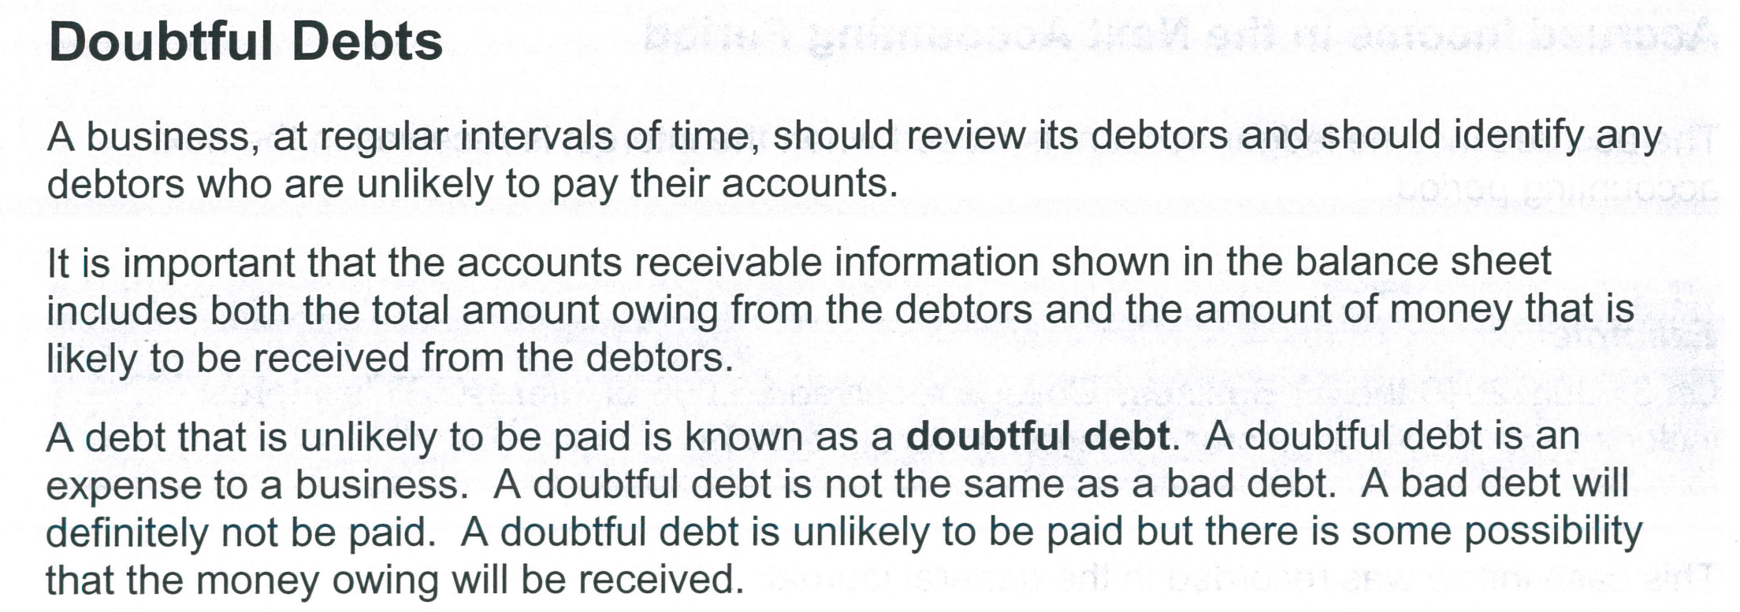

**1**

A doubtful debt is debited and an allowance for doubtful debts is credited. The allowance will reduce accounts receivable.

**1**

1. Why would unearned fees income be recorded as a current liability and not income. Explain the nature of unearned fees income using the Framework definition. (3 marks)

1 mark for explaining when unearned fees is income

1 mark for giving the Framework definition of a liability

1 mark for applying the definition to unearned fees.

Eg.

Only when the accrual system of accounting is used is unearned fees recorded as a liability. Using the accrual system when the money for unearned fees is received it would be recorded a current liability (unearned fees). However, if the cash system of accounting was used when the money is received for unearned income is received it would be recorded as income. This is because using the accrual system the unearned fees is only recorded as income once the service has been completed (1)

The framework definition of a liability is ‘a present obligation of the entity to transfer an economic resource as a result of past events.’ (1)

Using the accrual system of accounting and applying the definition of a current liability to unearned fees it is:

* A present obligation of the business to complete a service in the future.
* The transfer of an economic resource is ‘the service’ being given or if the customer cancels the service ‘the money’ would need to be returned to the customer.
* Therefore, the business could be presently obliged to transfer money (an economic resource) back to the customer as a result of past events (the customer paying in advance).
* OR the business is presently obliged to give a service (an economic resource) as a result of past events (the customer paying in advance). (1)

**Question 11 Molly Meldrum Solution 27 marks**

**Workings**Insurance expense 9,000 x 3/12 = 2,250 (1)*

Rent expense 12,000 x 3/6 = 6,000 (1)*

Stationery expense 9,540 – 7,430 = 2,110 (1)*

Interest expense $400,000 x 0.09 x 3/12 = $9,000 (2)*

Wages & Salaries Expense (2 marks)

|  |  |  |  |  |  |
| --- | --- | --- | --- | --- | --- |
| 30/6 | Balance b/d (1/2) | 372,500 | 30/6 | P & L (1/2) | 385,000 |
|  | Accrued Expenses (1) | 12,500 |  |  |  |
|  |  | 385,000 |  |  | 385,000 |
|  |  |  |  |  |  |

Stationery Supply Expenses (2.5 marks)

|  |  |  |  |  |  |
| --- | --- | --- | --- | --- | --- |
| 30/6 | Stationery supplies | 2,110(2)* | 30/6 | P & L (1/2) | 2,110 |
|  |  | 2,110 |  |  | 2,110 |
|  |  |  |  |  |  |

**Insurance Expenses** (1.5 marks)

|  |  |  |  |  |  |
| --- | --- | --- | --- | --- | --- |
| 30/6 | Prepaid insurance expense | 2,250(1)* | 30/6 | P & L (1/2) | 2,250 |
|  |  | 2,250 |  |  | 2,250 |
|  |  |  |  |  |  |

**Prepaid Insurance** ( 2.5 marks)

|  |  |  |  |  |  |  |
| --- | --- | --- | --- | --- | --- | --- |
| 30/6 | Balance b/d | 9,000  (1/2) | 30/6 | Insurance expense | | 2,250 (1) |
|  |  |  |  | Balance c/d | | 6,750(1) |
|  |  | 9,000 |  |  | | 9,000 |
| 1/7 | Balance b/d | 6,750 |  | |  |  |

**Rent Expenses** **(1.5 marks)**

|  |  |  |  |  |  |
| --- | --- | --- | --- | --- | --- |
| 30/6 | Rent expense | 6,000(1)* | 30/6 | P & L (1/2) | 6,000 |
|  |  | 6,000 |  |  | 6,000 |
|  |  |  |  |  |  |

**Prepaid Rent** **(2.5 marks)**

|  |  |  |  |  |  |  |
| --- | --- | --- | --- | --- | --- | --- |
| 30/6 | Balance b/d (1/2) | 12,000 | 30/6 | Rent Expense | | 6 000 1) |
|  |  |  |  | Balance c/d | | 6,000 (1) |
|  |  | 12,000 |  |  | | 12,000 |
| 1/7 | Balance b/d | 6,000 |  | |  |  |

**Unearned Magazine Subscription (2.5 marks)**

|  |  |  |  |  |  |  |  |  |
| --- | --- | --- | --- | --- | --- | --- | --- | --- |
| 30/6 | Subscription Rev | | 698,400(1) | | | 30/6 | Balance b/d (1/2) | 964,000 |
|  | Balance c/d | | 265,600(1) | | |  |  |  |
|  | |  | | 964,000 | |  |  | 964,000 |
|  | |  | | |  | 1/7/18 | Balance b/d | 265,600 |
|  | |  | | |  |  |  |  |

**Magazine Subscription Revenue (1.5 marks)**

|  |  |  |  |  |  |
| --- | --- | --- | --- | --- | --- |
| 30/6 | P & L (1/2) | 698,400 | 30/6 | Unearned Subs (1) | 698,400 |
|  |  |  |  |  |  |
|  |  |  |  |  |  |

**Accounts Receivable (2.5 marks)**

|  |  |  |  |  |  |  |
| --- | --- | --- | --- | --- | --- | --- |
| 30/6 | Balance b/d (1/2) | 10,850 | 30/6 | Bad debt | | 2,000 (1) |
|  |  |  |  | Balance c/d | | 8,850 (1) |
|  |  | 10,850 |  |  | | 10,850 |
| 1/7 | Balance b/d | 8,850 |  | |  |  |

**Bad debts (2 marks)**

|  |  |  |  |  |  |
| --- | --- | --- | --- | --- | --- |
| 30/6 | Accounts receivable | 2,000(1)* | 30/6 | Allowance for doubtful debts | 2,000(1) |
|  |  | 2,000 |  |  | 2,000 |

**Allowance for Doubtful Debts (4 marks)**

|  |  |  |  |  |  |  |
| --- | --- | --- | --- | --- | --- | --- |
| 30/6 | Bad debts | 2,000(1) | 30/6 | Balance b/d (1) | | 1,000 |
|  | Balance c/d | 2,000 (1) |  | Doubtful debts | | 3,000 (1) |
|  |  | 4,000 |  |  | | 4,000 |
|  |  |  | 1/7 | | Balance b/d | 2,000 |

**Doubtful debts (2 marks)**

|  |  |  |  |  |  |
| --- | --- | --- | --- | --- | --- |
| 30/6 | Allowance for doubtful debts | 3,000(1)* | 30/6 | P&L (1) | 3,000 |
|  |  | 3,000 |  |  | 3,000 |

Dates (up to -2) Setting out (up to -2) (27 marks)